Project: Build Your First Active Directory (AD) Lab
I recently completed a project where I built a virtual Active Directory lab environment using VirtualBox, Windows Server 2022, and Windows 10/11. The goal was to simulate a small corporate network, configure a Domain Controller (DC), and join a client machine to the domain.
This project helped me gain practical experience with:
- Setting up an isolated virtual network
- Installing and configuring a Windows Server as a Domain Controller
- Managing users, groups, and organizational units (OUs) in Active Directory
- Joining a Windows client machine to the domain
The project is divided into 4 main parts, and each part covers specific tasks:

📌 Part 0: Prerequisites & Software
- Hardware requirements (RAM, CPU, Disk space)
- VirtualBox setup with Extension Pack
- Windows Server 2022 & Windows 10/11 ISO downloads

📌 Part 1: Lab Network Setup
- Creating a NAT Network in VirtualBox
- Configuring an isolated IP scheme (10.0.2.0/24)

📌 Part 2: The Domain Controller (DC)
- Creating the DC01 VM
- Setting a static IP address
- Installing Active Directory Domain Services (AD DS)
- Promoting the server to a Domain Controller with domain name CYBERLAB.LOCAL

📌 Part 3: The Client Workstation
- Creating the Windows 10/11 client VM
- Configuring DNS to point to the DC
- Joining the client machine to the CYBERLAB.LOCAL domain

📌 Part 4: Active Directory Tasks
- Creating an Organizational Unit (OU)
- Adding a user account (haroonz)
- Logging into the client machine with a domain user account

📌 Part 5: Applying a User Policy
- Created a new Group Policy Object (GPO) and linked it to the HR OU
- Configured a user policy (e.g., remove Recycle Bin from desktop)
- Forced policy update on the WIN10-Client using gpupdate /force
- Verified the policy applied successfully to the domain user account.

📌 Part 0: Prerequisites & Software

Step 1: I began by downloading and installing Oracle VM VirtualBox, which serves as the virtualization platform for creating and managing virtual machines.

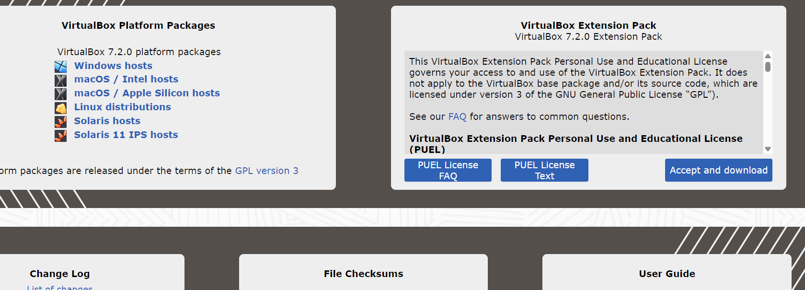
Step 2: Next, I downloaded the Windows 10 Enterprise ISO image, which was used as the client operating system within the virtual lab environment.

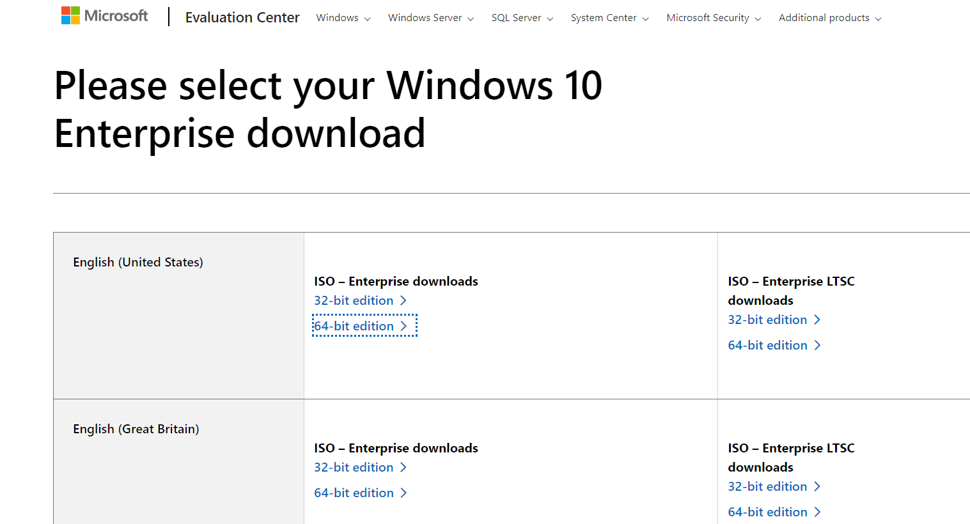
Step 3: I then downloaded the Windows Server 2022 ISO image, which was designated as the primary server operating system for configuring and managing the lab environment.

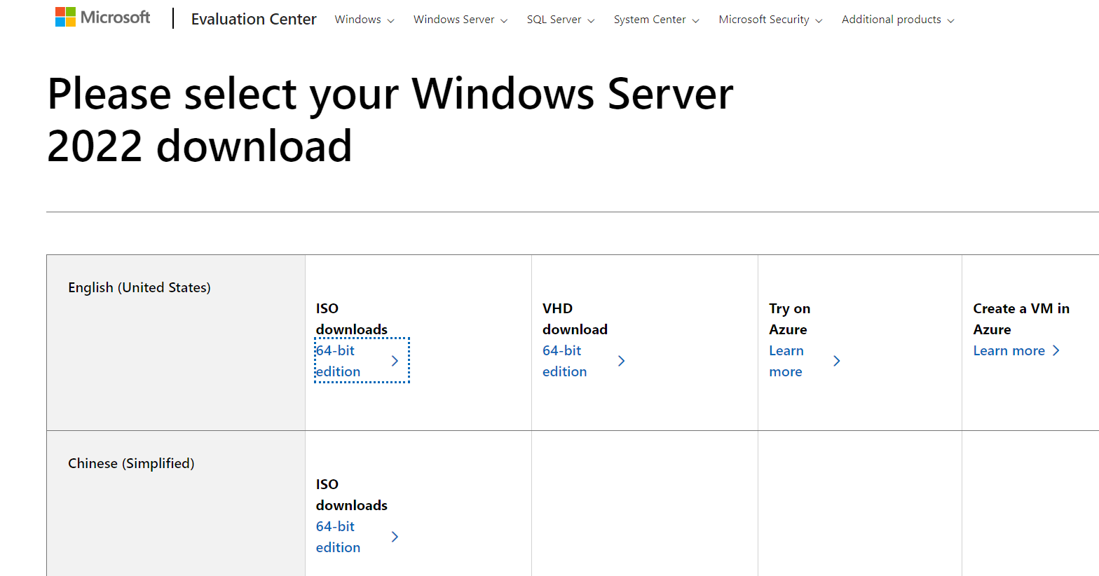

📌 Part 1: Lab Network Setup

Step 1: Upon launching VirtualBox, I navigated to the Network settings from the side panel. From the upper console, I selected NAT Networks to configure the virtual network environment for the lab.
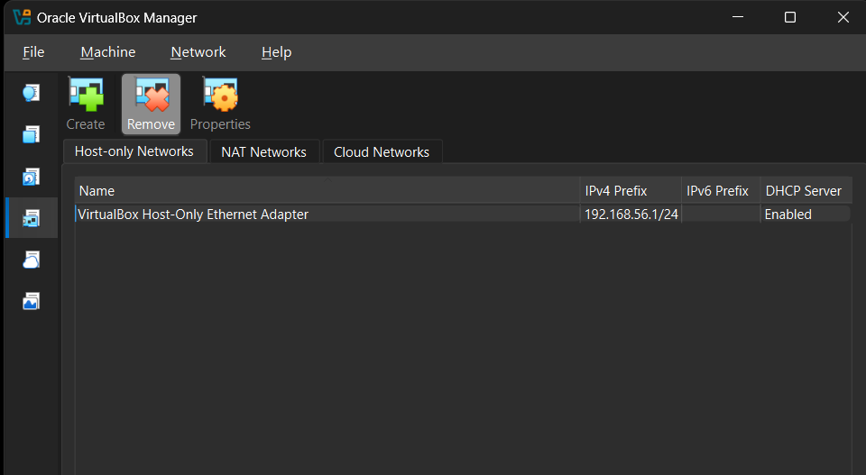

Step 2: Next, I clicked Create to set up a new NAT network. I named it “AD-Lab-Network”, assigned the appropriate IP address range, enabled DHCP, and then applied the settings to make the network ready for the virtual lab environment.
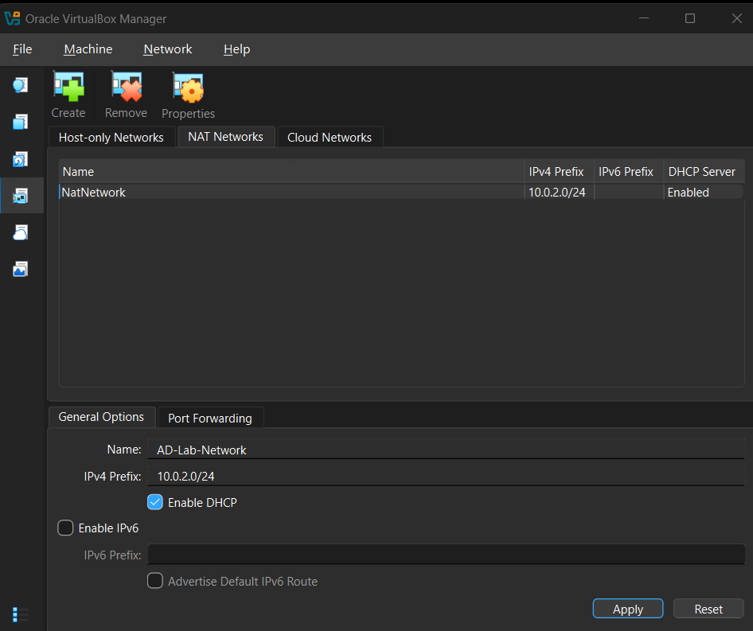

📌 Part 2: The Domain Controller (DC)
Step 1: To set up the Domain Controller using Windows Server, I created a new virtual machine by clicking New VM in VirtualBox. This VM will host the server operating system and Active Directory services for the lab environment
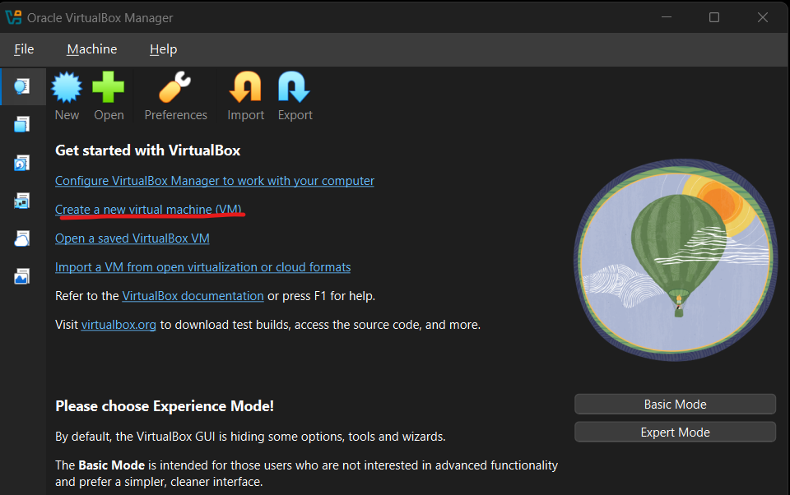

Step 2: Configure the VM for Windows Server
- I provided a name for the VM.
- Then selected the Windows Server 2022 ISO image previously downloaded.
- Choose the Desktop Experience edition.
- Left “Proceed with Unattended Installation” enabled to allow automatic installation.
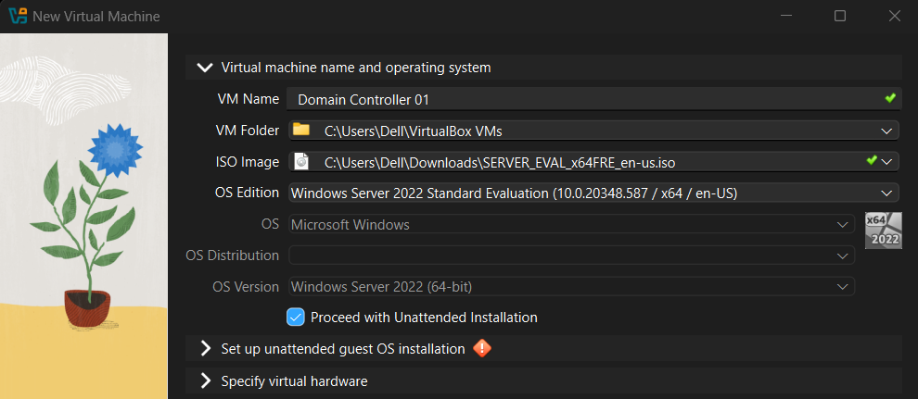
Step 3: Set Hostname and Administrator Credentials
- I selected a hostname for the virtual machine.
- I provided a username and password for the administrator account.
- This ensured a smooth and automated installation process without interruptions.
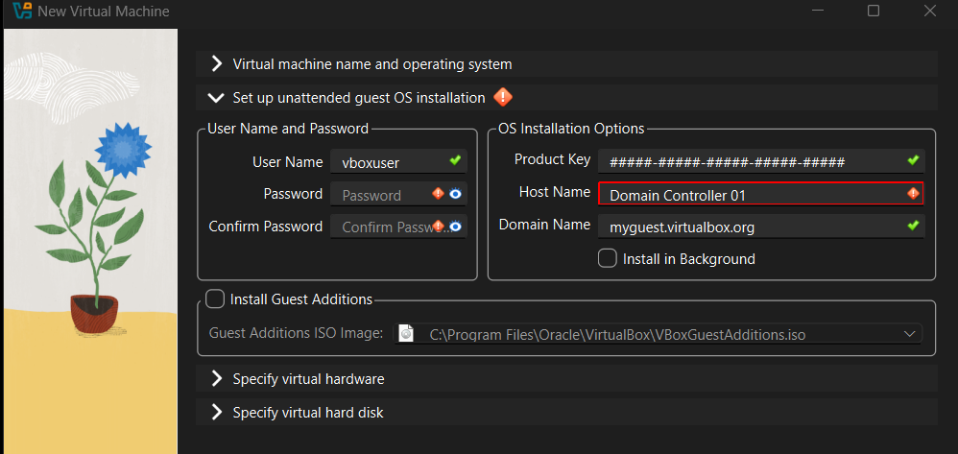

Step 4: Allocate Hardware Resources
- I specified the hardware configuration for the virtual machine.
- Assigned 2 GB of RAM and 2 CPU cores to ensure optimal performance during the installation and operation of the server.
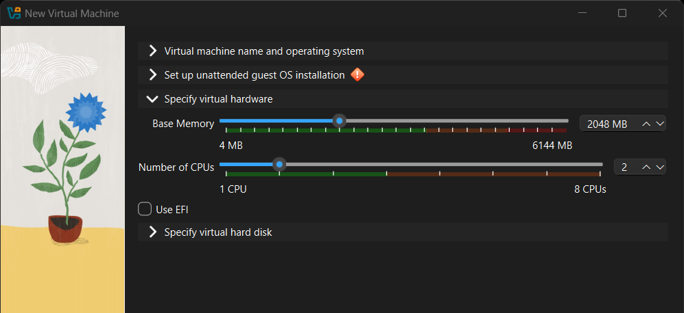
Step 5: Configure Storage for the VM
- I specified a virtual hard drive of 50 GB for the virtual machine to store the operating system and lab data.
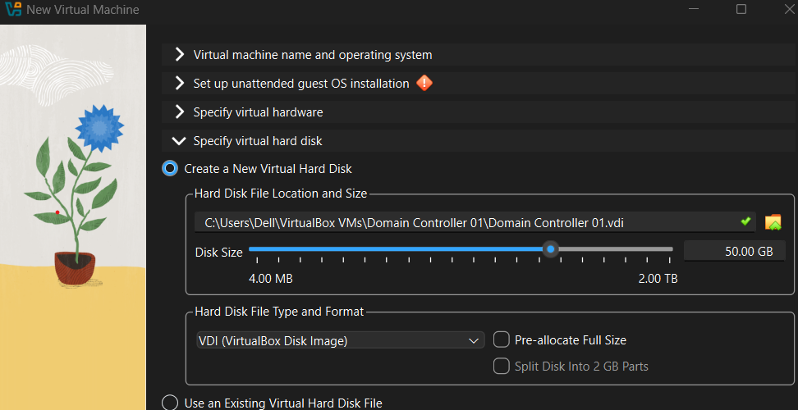

Step 6: Complete VM Configuration and Install Windows Server 2022
- After entering all the required details, I finished the Virtual Machine configuration wizard.
- At the end of the process, I had successfully installed Windows Server 2022 on my local machine.
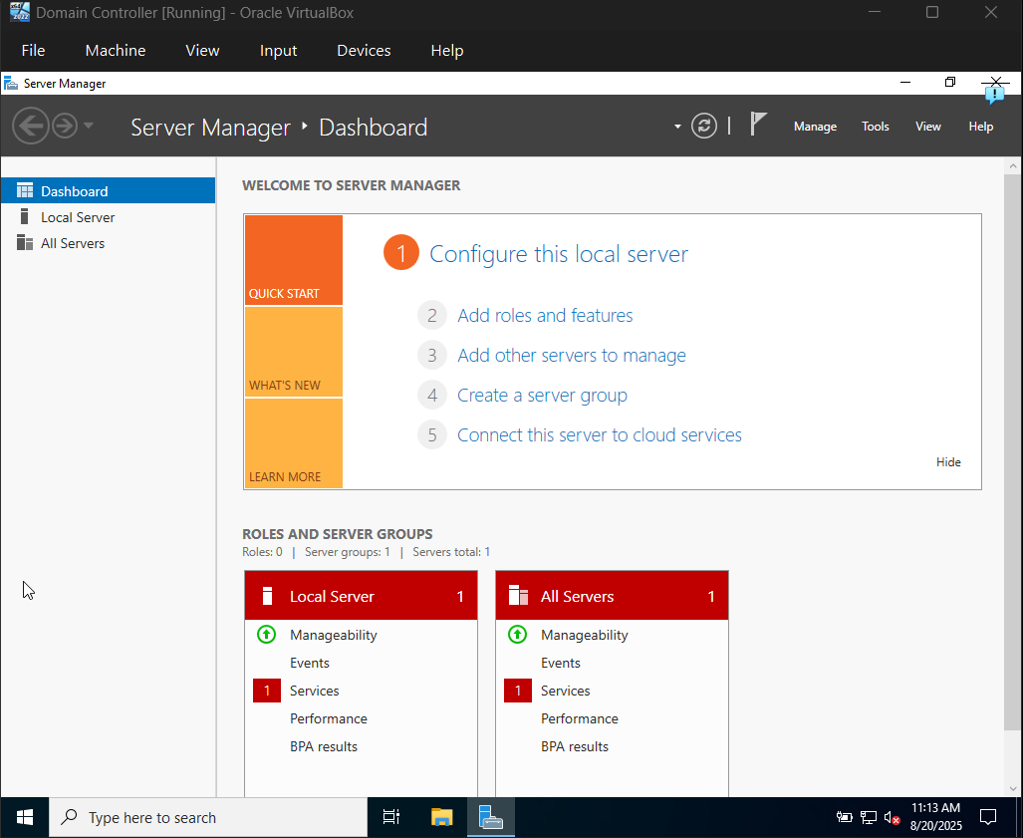

Step 7: Configure Networking for the Domain Controller
- I selected the Domain Controller 01 VM and clicked Settings → Network.
- Then changed “Attached to” to NAT Network.
- Ensured the “Name” dropdown displayed AD-Lab-Network.
- Clicked OK to apply the network settings.
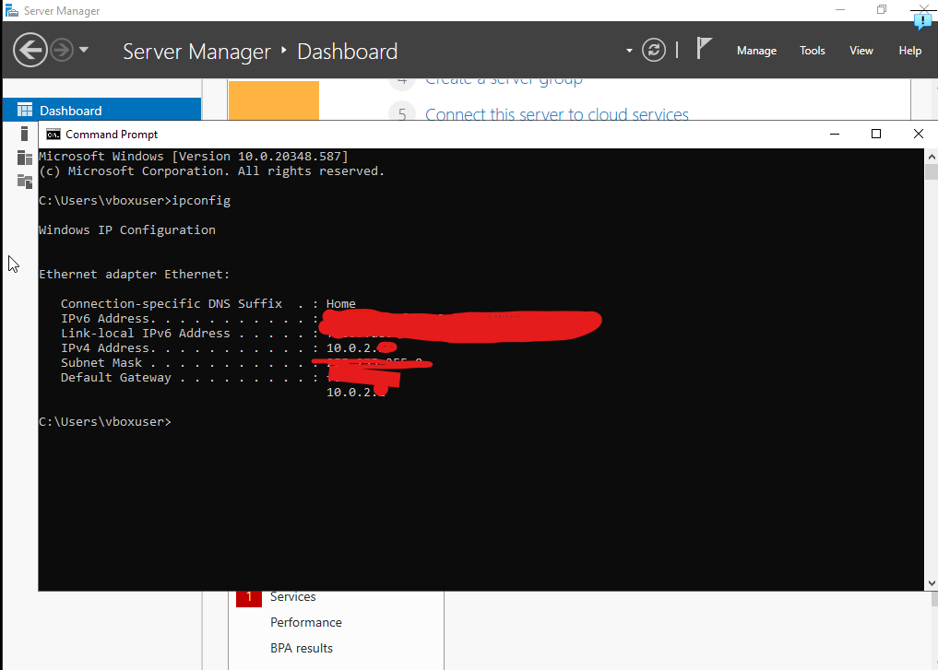
Step 8: Set the Static IP on Server
• Configured the server’s network adapter to use a static IP address, ensuring consistent network identification for the Domain Controller.
• This step is crucial for proper Active Directory and DNS functionality.
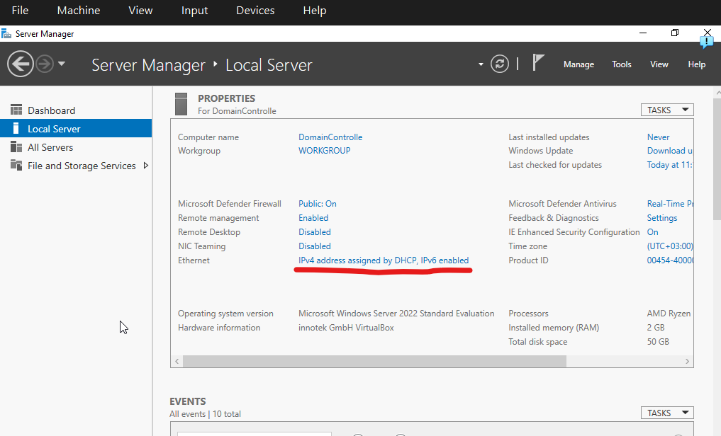

Step 8: Access Network Settings in Server Manager
- Opened Server Manager and clicked Local Server.
- Clicked the link next to Ethernet (which initially displays as “IP address assigned by DHCP”) to access the network adapter settings for further configuration.
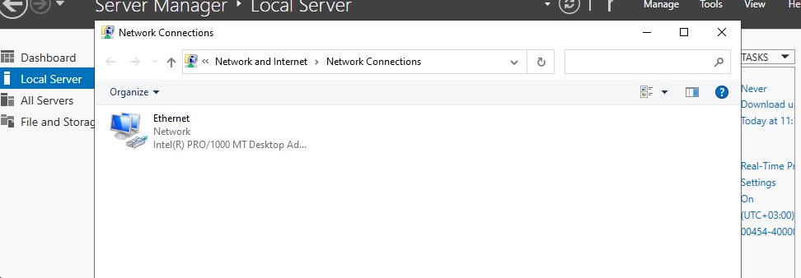
Step 9: Open IPv4 Properties
- Opened the Properties of the Ethernet adapter.
- Selected Internet Protocol Version 4 (TCP/IPv4) to configure the IP settings for the server.
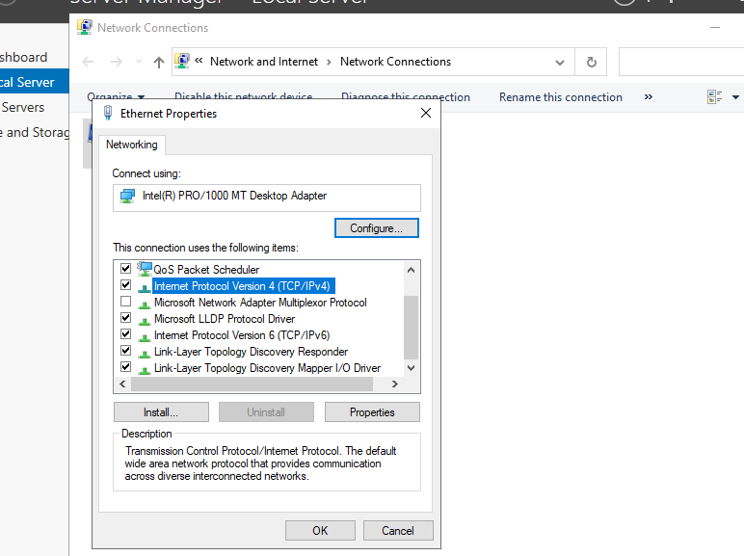

Step 10: Configure Static IP for the Domain Controller
- Configured the following settings:
  - IP Address: 10.0.2.10
  - Subnet Mask: 255.255.255.0
  - Default Gateway: 10.0.2.1
  - Preferred DNS Server: 127.0.0.1 (so the server queries itself for DNS, which is essential once Active Directory is installed)
- Clicked OK and Close.
- Noted that the server may briefly lose network connectivity, which is normal during the change.
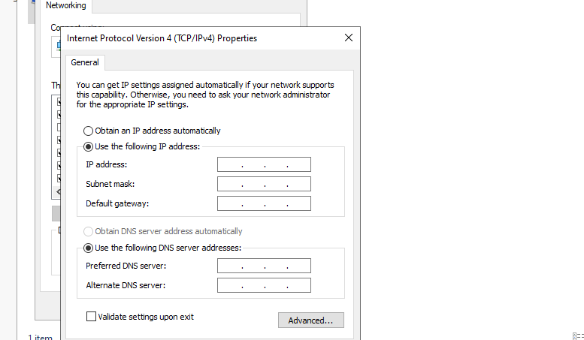

Step 11: Rename the Server Computer
- In Server Manager → Local Server, clicked the existing computer name.
- Renamed the computer to DC01 to reflect its role as the Domain Controller.
- Restarted the server to apply the new name.
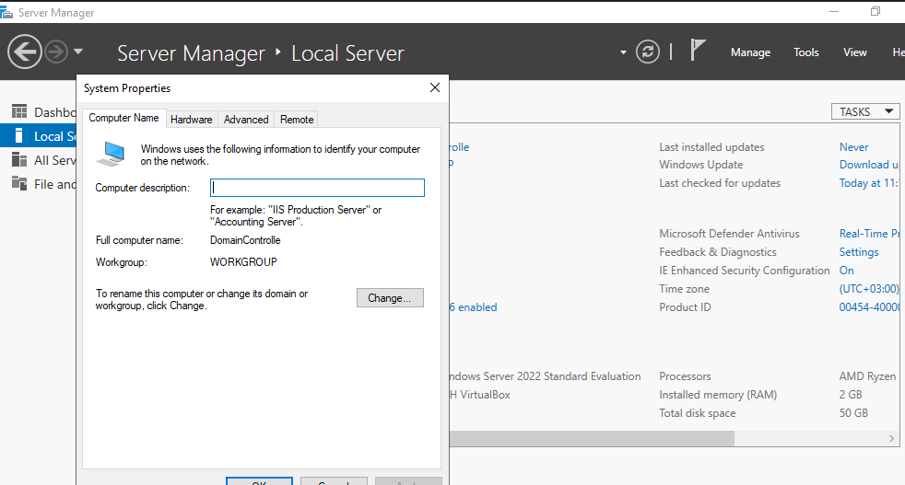
- After restarting the server this is what it looked like.
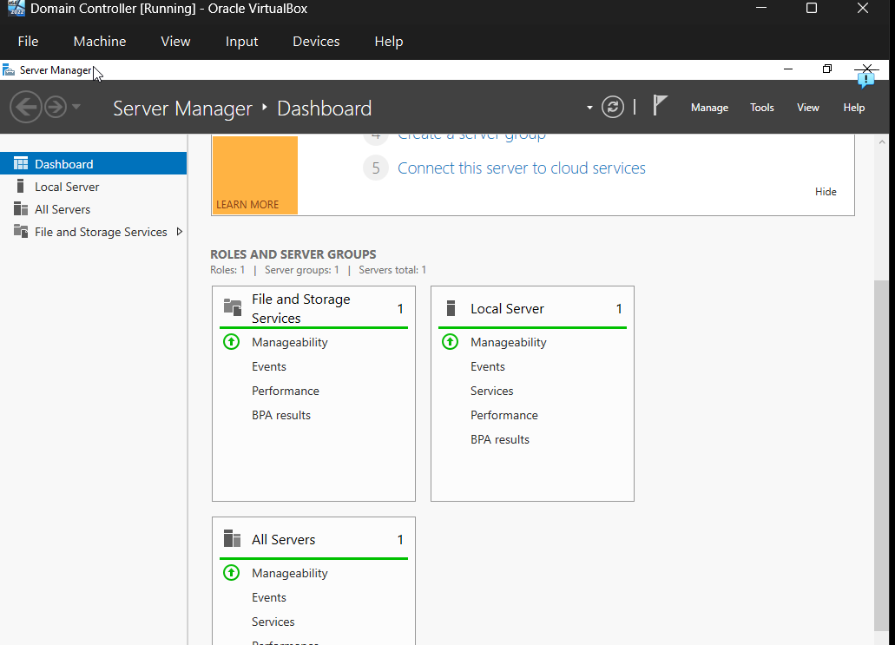

Step 12: Install and Promote Active Directory
- After restarting the server, opened Server Manager.
- Clicked Manage → Add Roles and Features.
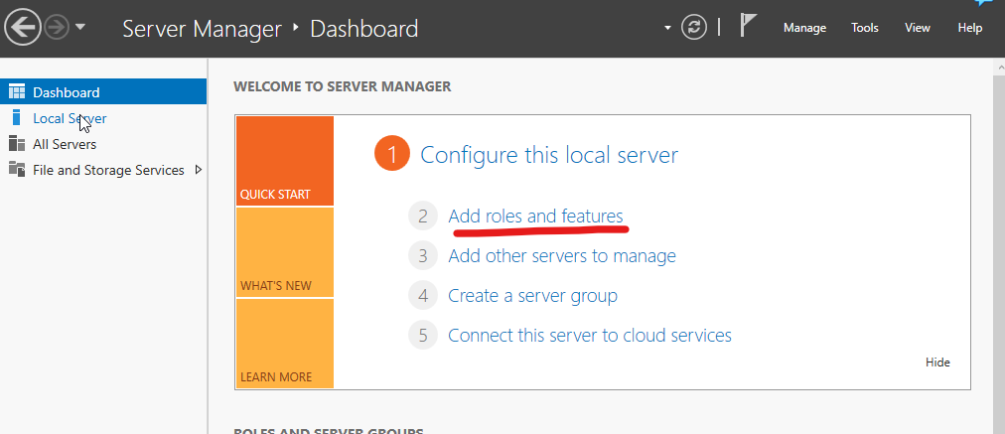
- Proceeded through the wizard by clicking next until reaching Server Roles.
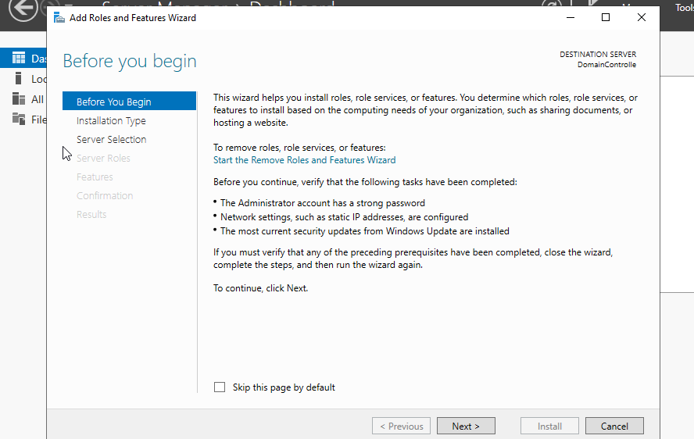
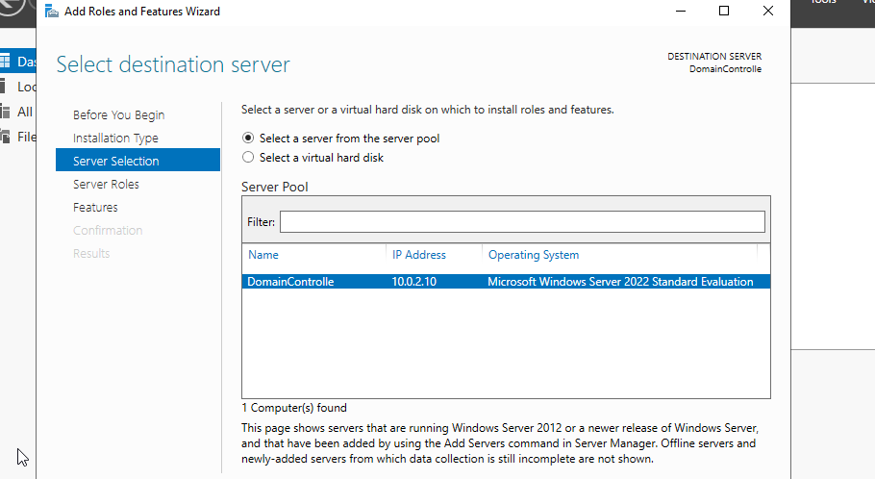
- Checked Active Directory Domain Services (AD DS) and accepted the prompt to add the required features.
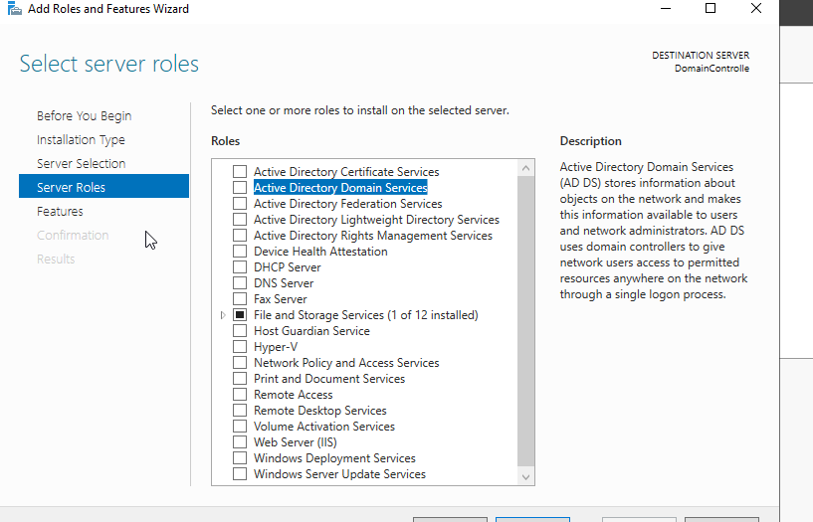
- Continued clicking Next and finally clicked Install to install the role.
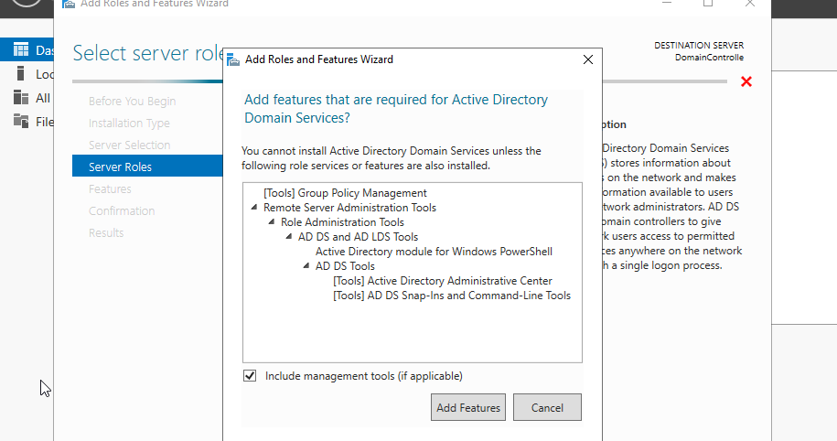
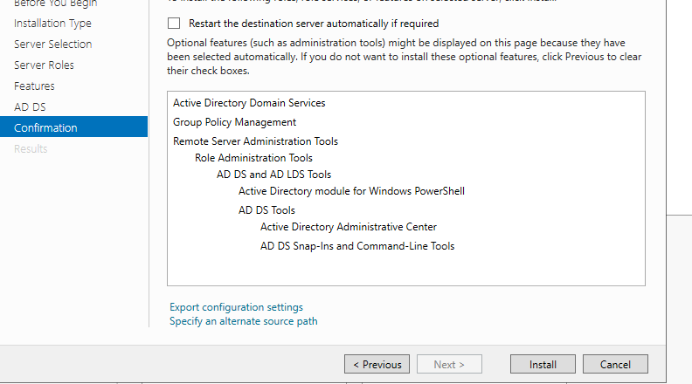

- After the installation completed, a notification flag appeared at the top of Server Manager.
- Clicked the flag and selected “Promote this server to a domain controller” to begin the domain configuration.
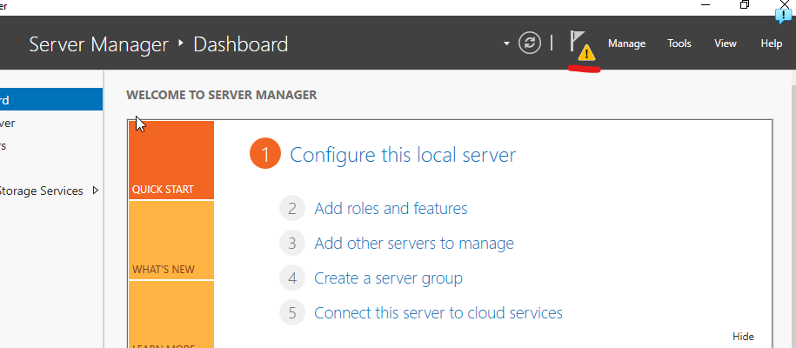
Step 13: Configure Active Directory and Promote to Domain Controller
- In the Active Directory Domain Services Configuration Wizard, I selected “Add a new forest”.
- Entered a root domain name, choosing a fictional domain to avoid conflicts with real internet domains. I used CYBERLAB.local.
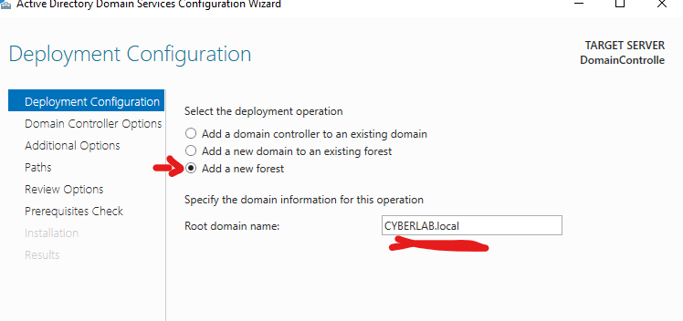
- On the next screen, I set a DSRM (Directory Services Restore Mode) password and noted it down securely.
- Clicked Next through the remaining screens, accepting the default options.
- Clicked Install, allowing the server to install Active Directory and restart automatically.

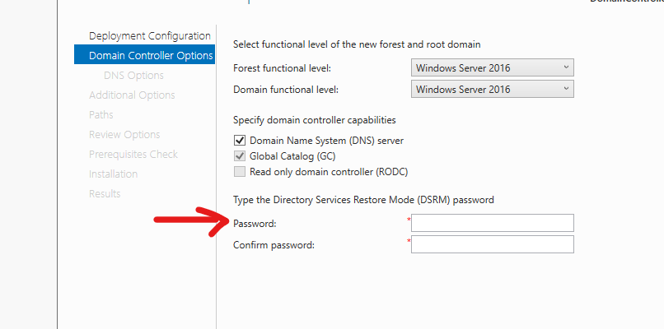
At the end of this process, DC01 was successfully promoted to a Domain Controller for the CYBERLAB.LOCAL domain.
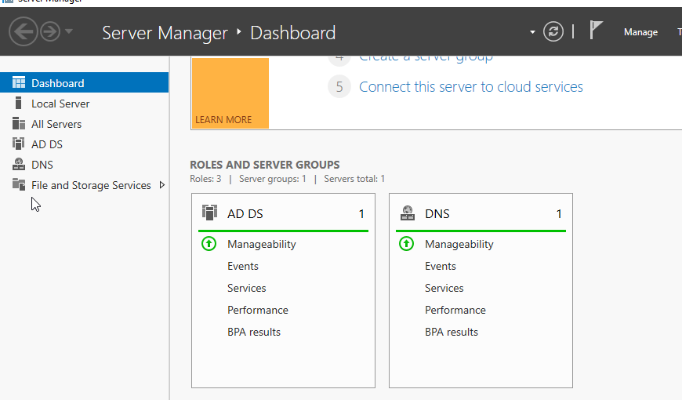

Part 3: The Client Workstation
Step 1: Create the Windows 10 Client VM
- I created a new virtual machine following the same procedure used for the server VM and named it WIN10-Client.
- Allocated 4 GB of RAM, 2 CPU cores, and a 40 GB virtual hard disk to ensure smooth performance for the client operating system.

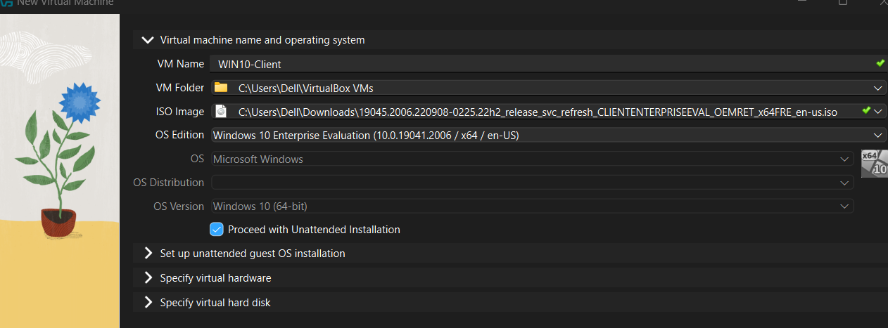
Step 2: Configure Networking and Install Windows 10 Client
- In WIN10-Client VM → Settings → Network, I attached the virtual machine to the same NAT Network (AD-Lab-Network) used by the Domain Controller.
- Started the VM and completed the Windows 10 operating system installation to set up the client machine within the virtual lab environment.
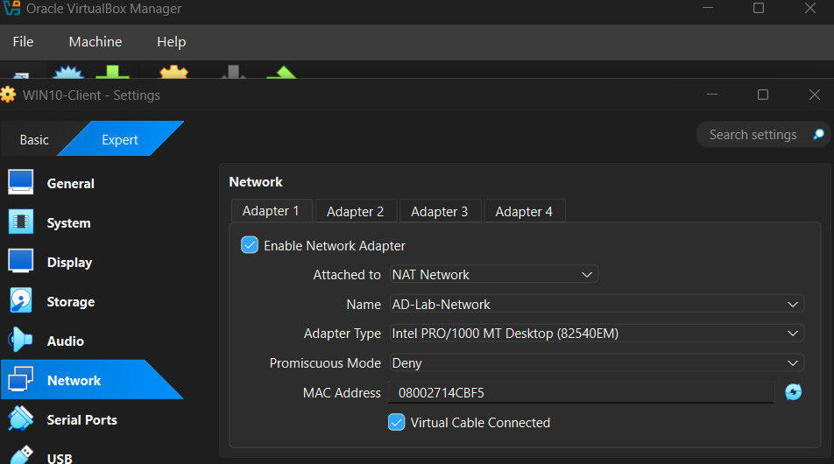

Step 3: Configure Client Networking
- After completing the Windows 10 installation, I configured the network settings to ensure the client uses the Domain Controller for DNS.
- Opened the network adapter properties, similar to the configuration done on the server.
- Set the IP address configuration to “Obtain an IP address automatically”.
- Set the Preferred DNS server to the Domain Controller’s IP address: 10.0.2.10.
This configuration ensures the client can properly communicate with the domain and access Active Directory services.
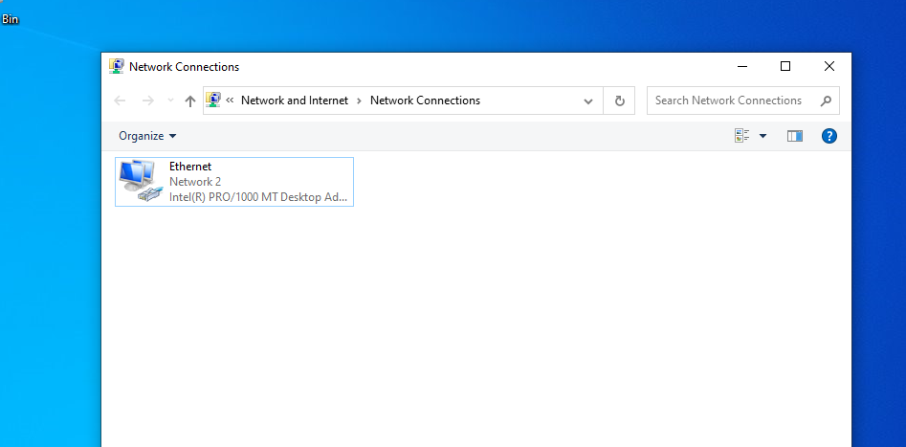
- Set the Preferred DNS server to the Domain Controller’s IP address: 10.0.2.10.
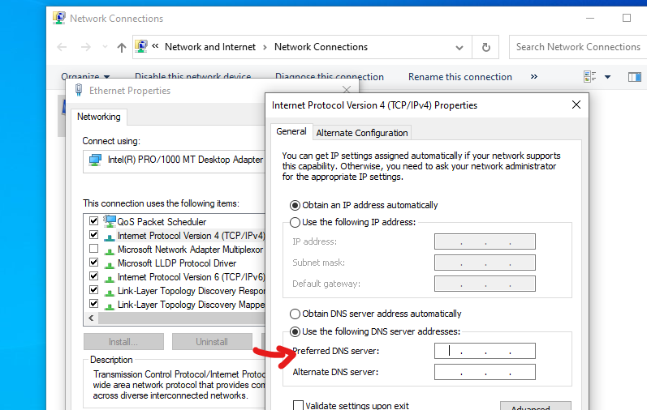
Step 4: Join the Client to the Domain
- I opened System Properties by right-clicking This PC → Properties → Rename this PC (advanced).
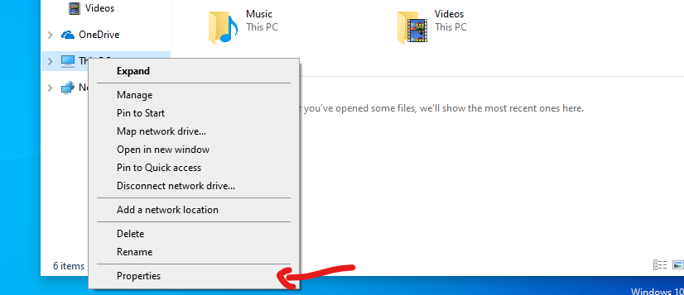
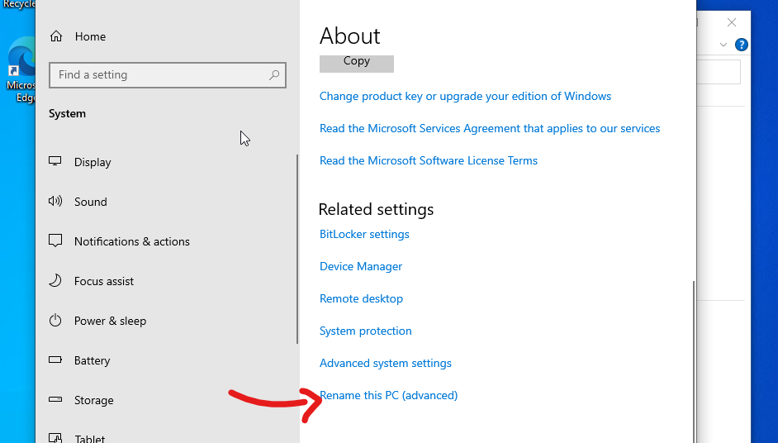

- Clicked the “Change…” button.
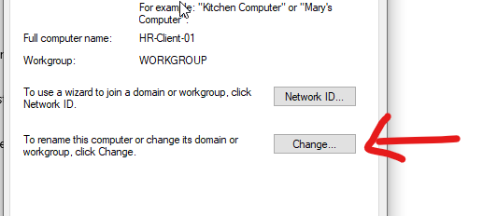
- Under “Member of”, selected Domain and entered the domain name: CYBERLAB.local.
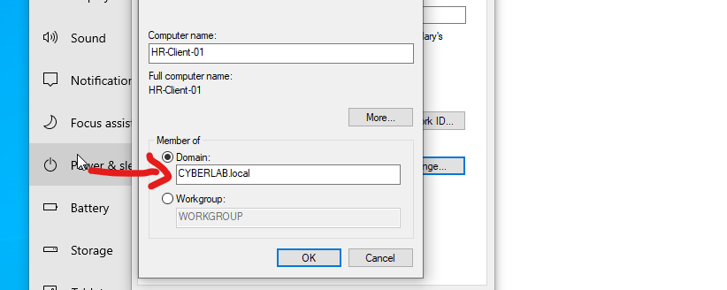
- Entered the administrator credentials for the domain (CYBERLAB\Administrator) along with the password set during the Windows Server setup.
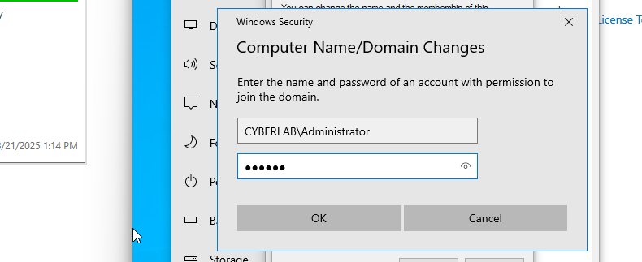

- Received the “Welcome to the CYBERLAB.LOCAL domain” message and restarted the client machine to complete the domain join process.
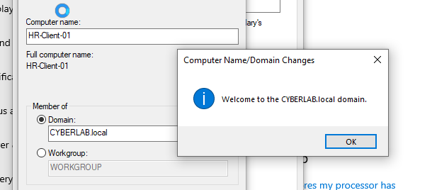
Part 4: Active Directory Tasks
Step 1: Creating Organization Unit (OU)
- Went back to the DC01 server. In Server Manager, navigated to Tools → Active Directory Users and Computers.
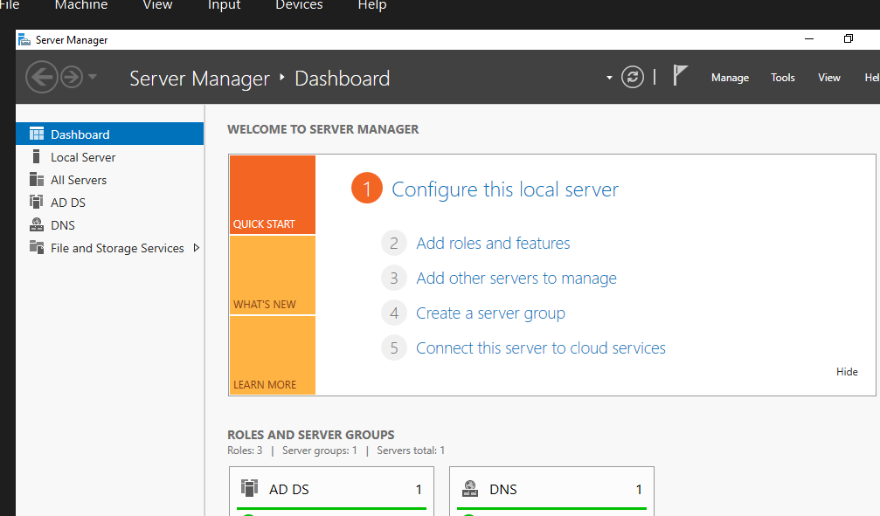

- Right-clicked the domain (CYBERLAB.LOCAL) and selected New → Organizational Unit.
- Named the OU HR.
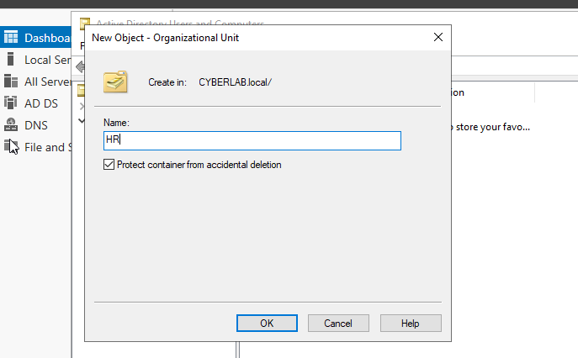
Step 2: Create a User:
- Right-clicked the HR OU and selected New → User.
- Filled in the details to create a user named Haroon Zaman.
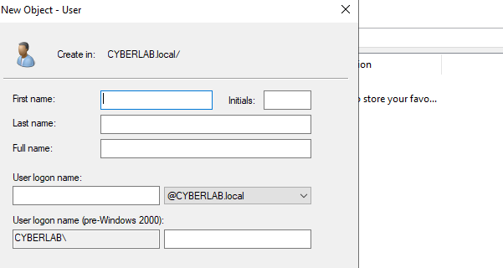

- Set a password for the user and checked the option “User must change password at next logon”.
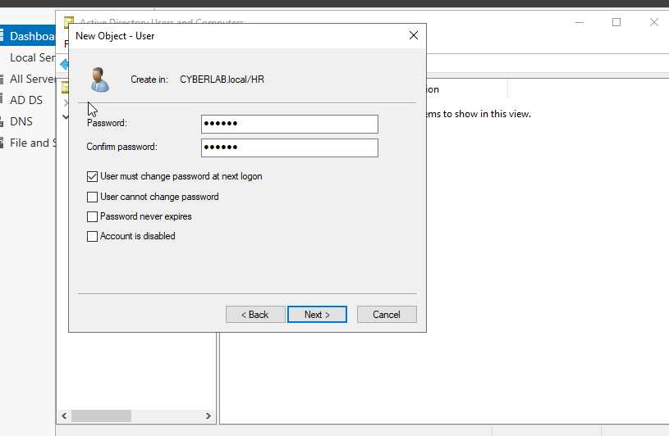
- Gave a final check before clicking finish.
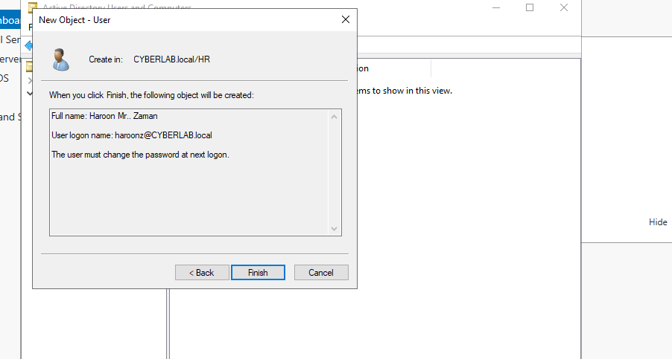

From the HR OU, I was able to edit all aspects of the user account, including:
- Changing the password
- Modifying the logon name
- Unlocking the account
- Configuring any other settings related to the account or password
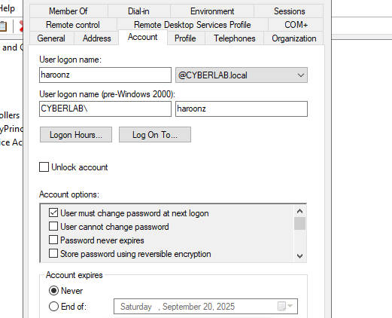
- I can make this user to a specific group member or remove it also.
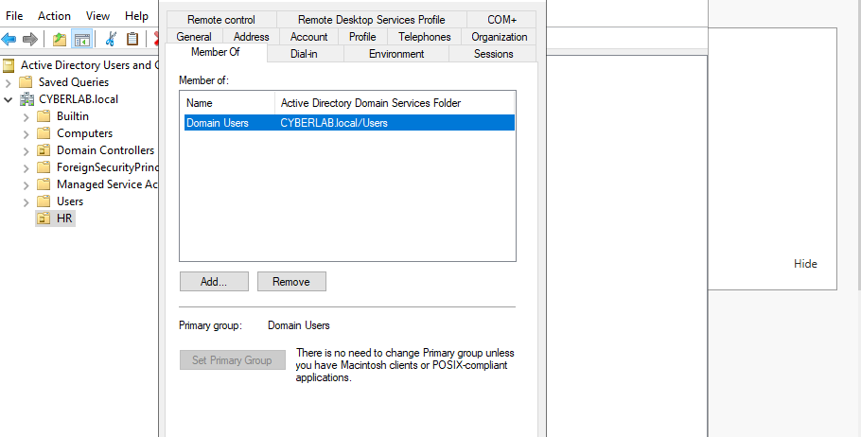

Step 3: Log In as the New User
- Went to the WIN10-Client VM. At the login screen, clicked Other user.
- Signed in using the new domain account:
  - Username: CYBERLAB\haroonz
  - Password: The password set during user creation
- Successfully logged into the domain-joined machine with the domain user account.
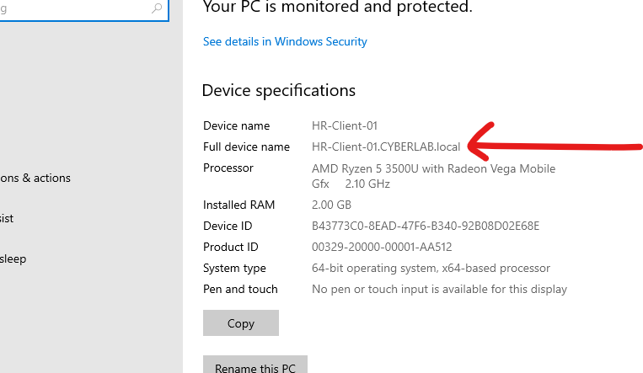

Part 5: Applying a User Policy
Step 1: Create a Security Group and Add Members
- Created a new security group named HR-Files in Active Directory Users and Computers.
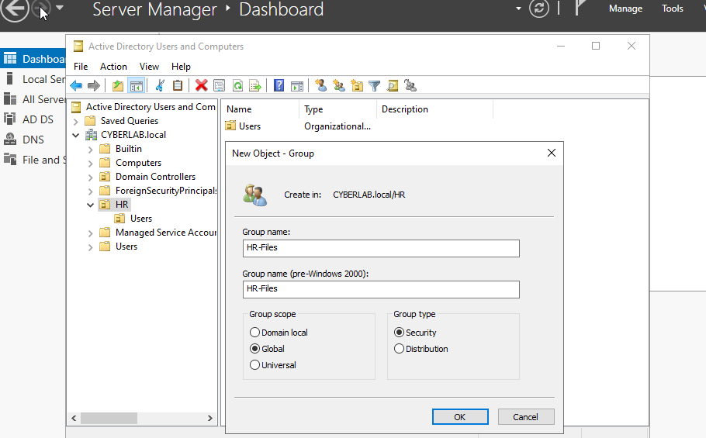
- This is security group created.
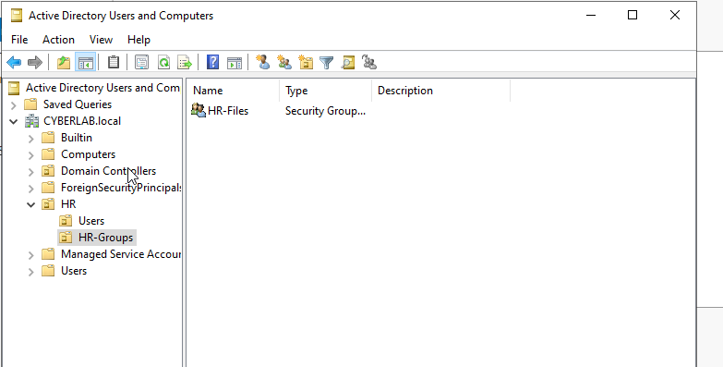

- Added Haroon as a member of the HR-Files group.
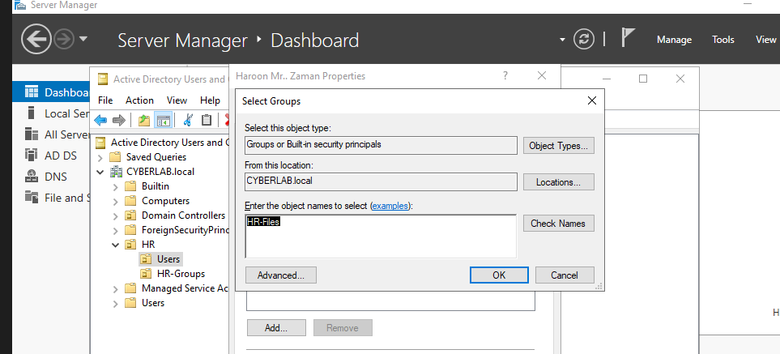
Step 2: Create a Group Policy Object (GPO) for HR
- Opened Group Policy Management from Tools in Server Manager.
- Expanded the domain CYBERLAB.LOCAL → HR.
- Right-clicked the HR OU and selected “Create a GPO in this domain, and Link it here…” to create a new Group Policy Object for the HR group.
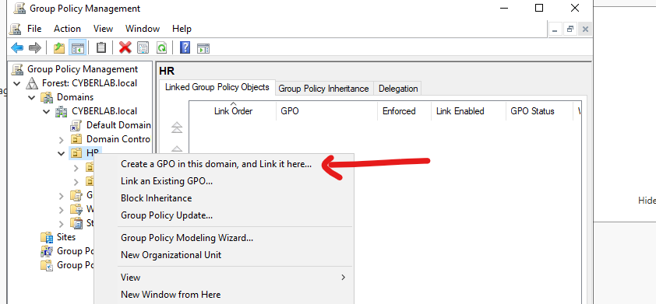

Step 3: Configure Security Filtering for the GPO
- After creating the GPO for the HR OU, I proceeded to configure Security Filtering.
- This step ensures that the policy applies only to the intended users or groups, in this case, members of the HR group.
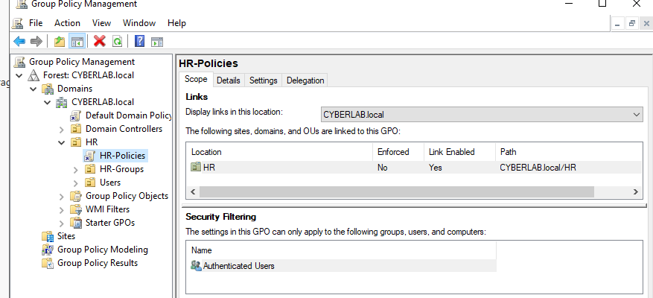
Step 4: Remove Authenticated Users from Security Filtering
- Removed Authenticated Users from the Security Filtering section of the GPO.
- This ensures the policy applies only to the specified HR group members and not to all users in the domain.
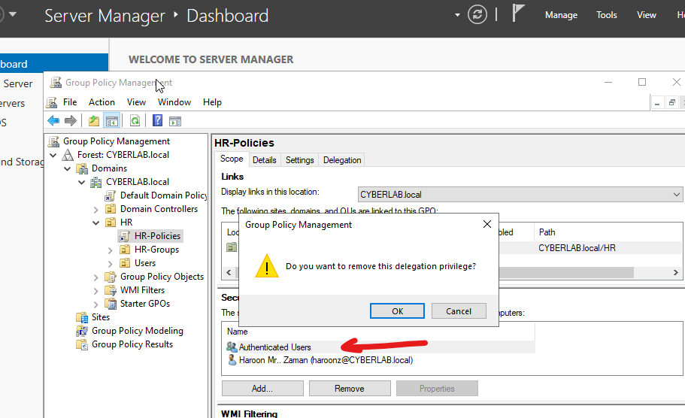

Step 5: Configure Delegation for Granular Control
- Accessed the Delegation tab in the GPO settings.
- Added or removed users/groups to control who can modify or apply the GPO, providing more granular control over policy filtering.
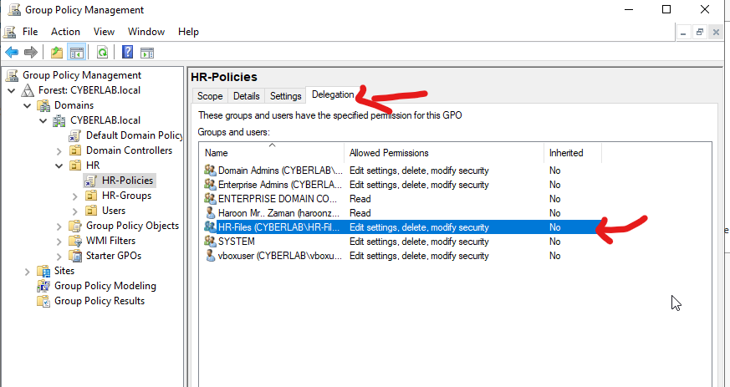
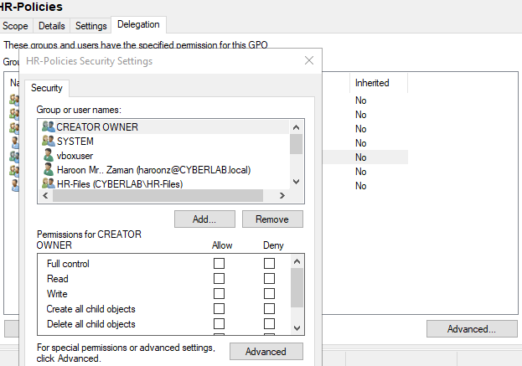
Step 6: Edit the HR GPO to Configure Policies
- Navigated to the HR OU in Group Policy Management.
- Right-clicked on HR-Policies and selected Edit.
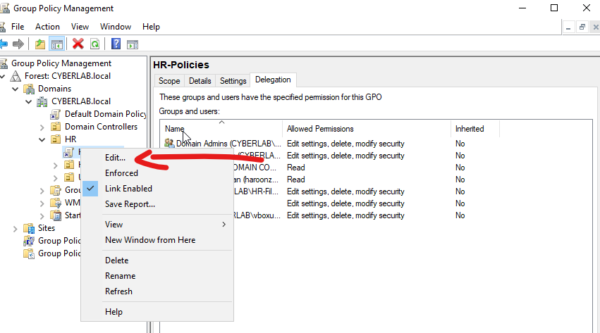

- This opened the Group Policy Management Editor, where I could set and configure specific policies for the HR group.
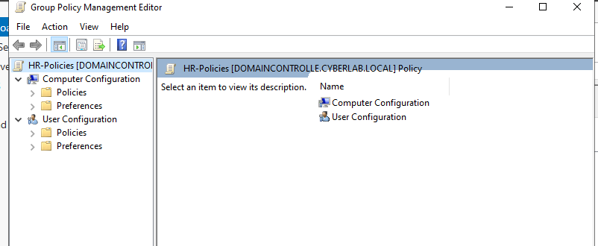

Step 7: Configure Policy to Remove Recycle Bin on Client
- Navigated to User Configuration in the Group Policy Management Editor, since the policy is applied to users.
- Went to Policies → Administrative Templates → Desktop.
- Double-clicked Desktop to open the available options on the right-hand pane for configuring user desktop settings.
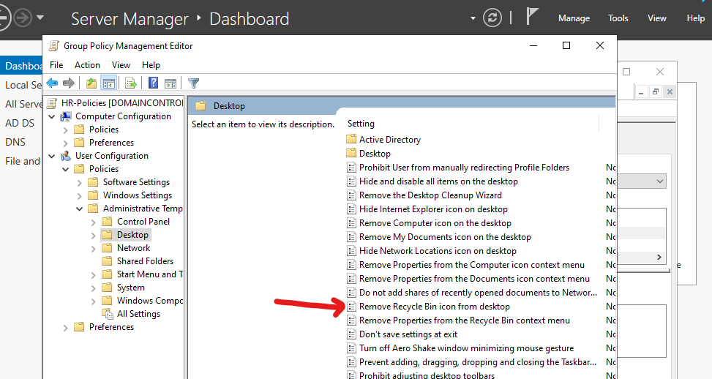
Step 8: Enable the “Remove Recycle Bin from Desktop” Policy
- Clicked on the “Remove Recycle Bin from Desktop” setting.
- In the window that opened, selected Enabled.
- Clicked Apply to enforce the policy for users in the HR group.
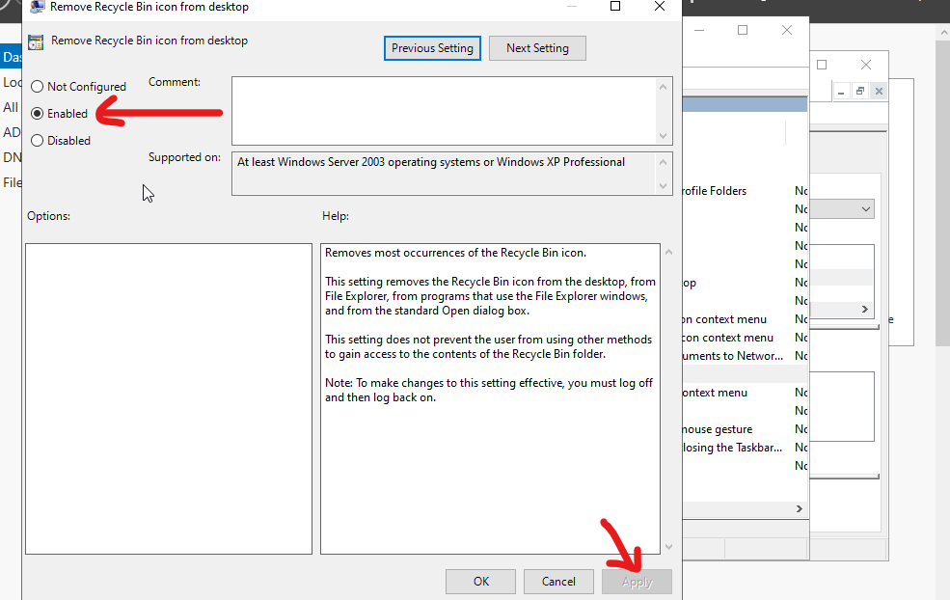

Step 10: Troubleshooting GPO Issues on a Client Machine

1. Verify GPO Linking
- Ensure the GPO is linked to the correct OU, domain, or site where the client machine resides.
- Check that the user or computer object is in the OU where the GPO is linked.

2. Check Security Filtering
- Go to the GPO Security Filtering tab.
- Make sure the user or computer group you want the policy applied to is listed.
- Remove Authenticated Users if you only want the policy applied to specific groups.
- Verify the account has Read and Apply Group Policy permissions.

3. Check WMI Filtering
- If a WMI filter is applied to the GPO, verify that the client matches the filter conditions.
- Misconfigured WMI filters can prevent the GPO from applying.

4. Confirm the Client’s Network Connection
- Ensure the client can communicate with the Domain Controller.
- Test by running ping <DC-IP> or checking DNS resolution of the domain (nslookup <domain>).

5. Force a Group Policy Update
- On the client, run:
- gpupdate /force
- Then check if the policy applied.
- For user policies, log off and log back in; some policies require a reboot.

6. Check Applied Policies
- Run the following command on the client to see which GPOs are applied:
- gpresult /r
- Review both User and Computer settings to ensure the intended GPO is listed.
- If it shows N/A or the GPO is missing, it indicates filtering, permissions, or network issues.

7. Review Event Logs
- Open Event Viewer → Applications and Services Logs → Microsoft → Windows → GroupPolicy → Operational
- Look for errors or warnings related to GPO application.

8. Check Policy Type
- Confirm you are editing the correct section:
  - User Configuration policies apply to users.
  - Computer Configuration policies apply to computers.
- Applying a user policy to a computer object will not work and vice versa.

9. Check Replication
- In multi-DC environments, verify that GPO replication is complete and consistent across all Domain Controllers.

10. Other Considerations
- Some policies require specific Windows editions (e.g., Enterprise vs. Home).
- Check for local policies or conflicting GPOs that may override the settings.

✅ Tip: Always start with gpresult /r or the RSOP (Resultant Set of Policy) tool to quickly see what policies are applied and troubleshoot why a policy isn’t taking effect.
- Before applying the Policy
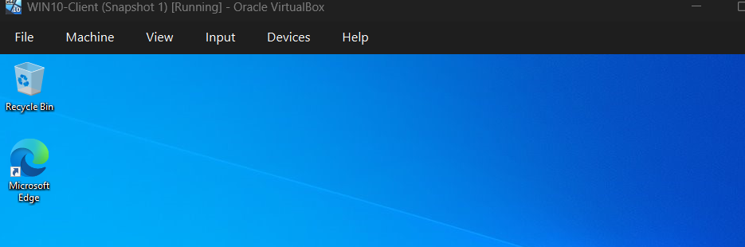
- After applying the Policy, The Recycle Bin is removed from the Desktop
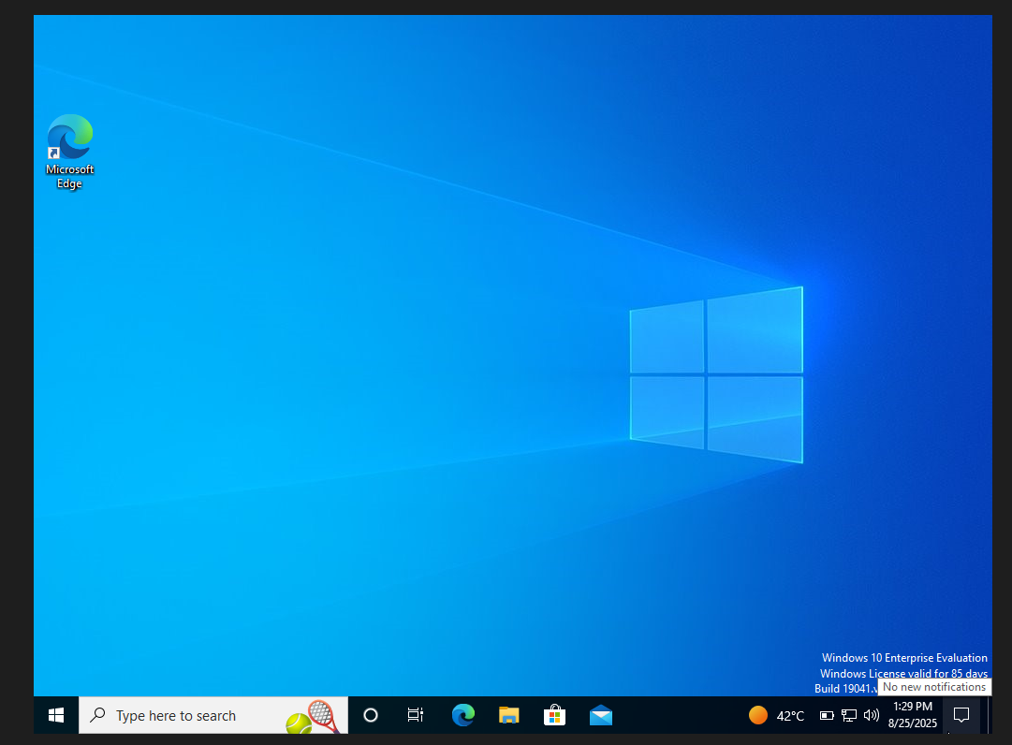

Check if Policy is Applied
- On the Client VM, open Command Prompt.
- Type:
- gpresult /r
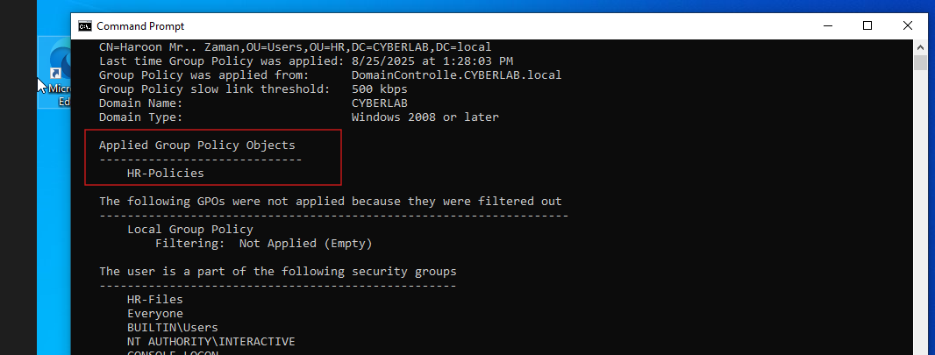
Step 9: Link the GPO and Verify on Client
- Linked the HR-Policies GPO to the HR OU in Group Policy Management.
- On the client machine, logged in as a user in the HR group.
- Verified that the Recycle Bin was successfully removed from the desktop, confirming the policy was applied correctly.
Conclusion
In this lab, I successfully built a complete Active Directory environment using Windows Server 2022 and a Windows 10 client machine in VirtualBox. I learned how to:
- Install and configure Windows Server as a Domain Controller.
- Set static IP addresses and DNS settings for proper network communication.
- Create and manage Organizational Units (OUs), users, and groups within Active Directory.
- Join client machines to the domain and verify user authentication.
- Create and apply Group Policy Objects (GPOs), including user-specific policies like removing the Recycle Bin.
- Configure security filtering and delegation to control policy application at a granular level.
Through this project, I gained practical experience in network planning, Active Directory management, and user policy enforcement, which are crucial skills for IT and network administration roles.
Other learners can use this lab to understand the core concepts of Active Directory, how to structure a domain environment, and how Group Policies can be used to manage user settings and security effectively. By following similar steps, they can build a safe, controlled lab environment to practice Active Directory administration without impacting real-world networks.

